Final Project I AESM3030
A single-phase 1D hydrogen
storage reservoir simmulation
Authors:
- Keith Polak (4724747)
- Nanda Afif (6424732)

Datum: April 2026
MSc. Earth, Climate, and Technology

Final Project II AESM3030
A single-phase 1D hydrogen storage reservoir simmulation

Contents
1 Abstract 5
2 Formulations and Method 6
2.1 Mathematical Formulations, Discretization, and Simulation Approach 6
2.2 Boundary and Initial Conditions 7
3 Results 8
3.1 Models for permeability and pressure distributions 8
4 Discussion 10

Abstract
This study presents the influence of well production and injection in a 2D subsurface. The pressure difference between a well and the reservoir is radially distributed, until there is no difference anymore. The migration of CO2 is mostly circular, but tends to go towards locations with higher permeability.

Formulations and Method

Mathematical Formulations, Discretization, and Simulation Approach
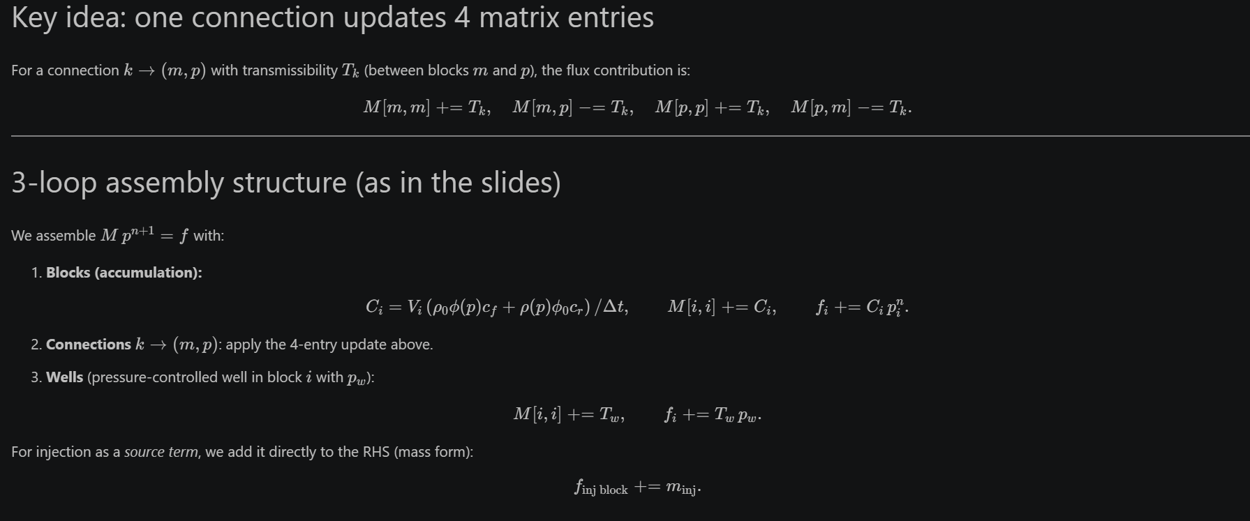
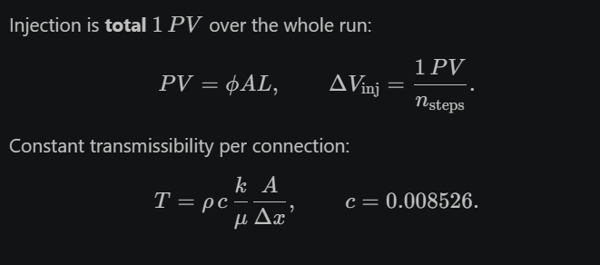
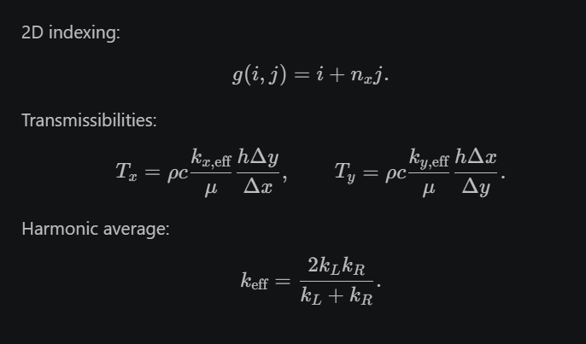
The formulation for this assignment comes from the practical 5-6-7 of the course. This code has been used with the parameters given in this assignment. All constants also come from the practicals. Viscosity mu of water has been set as 1. Permeability was found in the egg models. c was set as 0.008526, like in the practical. Phi was set as 0.3
For the 4th question, the code from lecture 8 was adapted and reused.

Boundary and Initial Conditions
The reservoir is subject to sealed (no-flow) boundary conditions. At the left boundary ($x=0$) and the right boundary ($x=L$), the pressure gradient is zero, i.e. $\frac{∂p}{∂x}=0$, indicating no fluid flow across the boundaries. The initial condition assumes a uniform pressure distribution throughout the reservoir, given by $p(x,y,t=0)=150$ bar. The injector injects with a pressure of 200 bars. The producer has a pressure of 100 bars. Permeabilities come from the egg models (31 and 72) in the 4th layer.

Results

Models for permeability and pressure distributions
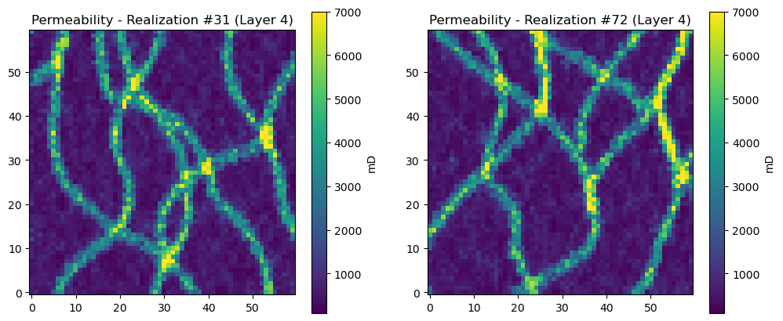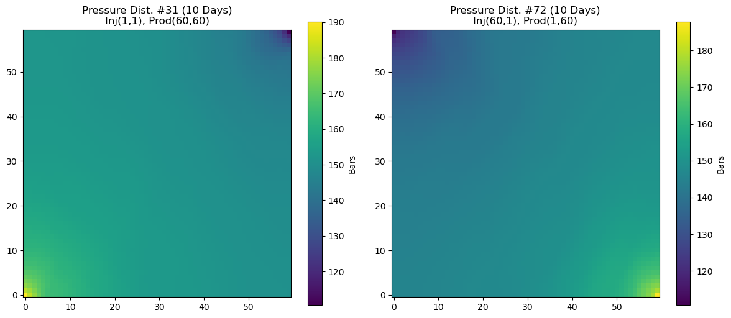
The figures above show the results of the code. The top graph clearly show channels with high permeability. The figure below that shows the pressure distribution. As expected, the blocks near the injector have high pressure. The blocks near the producer show decreased pressure.

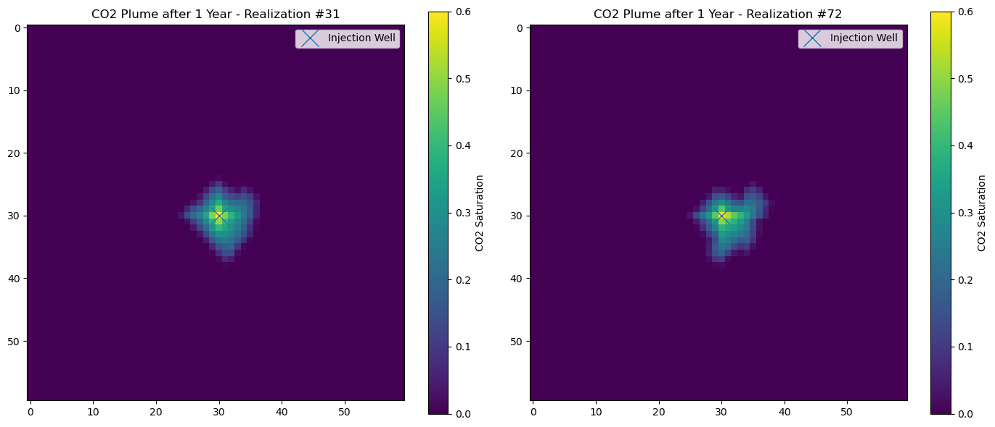
The figure above shows the spread of the CO2 plume after 1 year. As expected, the CO2 is saturated near the well. This is happening because of the injection there. The CO2 saturation decreases when we go away from the well, until the saturation is 0. As can be seen, the CO2 has not fully saturated the reservoir. Only a part of the reservoir has CO2

Discussion
The results show that the pressure in a reservoir change when injecting/ producing. This is of course, as expected. The pressure here is radially distributed. The CO2 moves radially away well. It does not move as much as we expected after 1 year. Perhaps this is because of the location of the well. When we look at the location of the well, we find the layer to have low permeability. Perhaps this is the reason the CO2 has not moved as much. The shapes of the plume are also, as expected, different. 31 is relatively circular, but 72 protrudes more towards the south east. Perhaps this is because of the high permeable zone to the southwest of well 72



